**Activity 19**

**NAME : Shalini devi.M COURSE : Mobile Computing**

**Reg No : 192421351 COURSE CODE: ITA0302**

Develop a user interface prototype for an Android application using Figma.

**Aim:**

To Develop a user interface prototype for an Android application using Figma.

Procedure:

1. Create a file
2. Add The First Frame
3. Add Shapes
4. Add Text
5. Create The Second Frame
6. Add Prototyping

Step By Step Procedure : Interface Of Experiment:

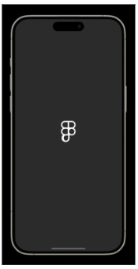

Next Page:

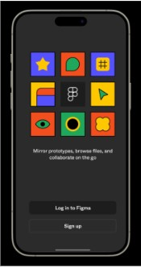

Login And Signup Page:

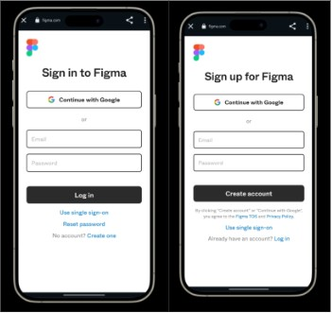

Final Step:

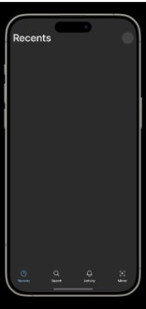

Prototype:

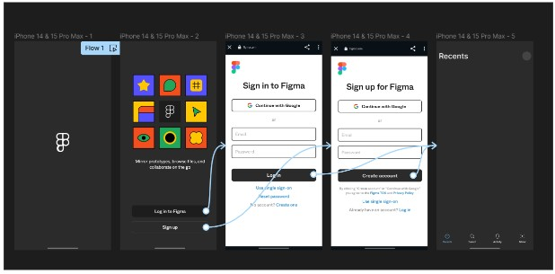

**Result:**

Hence the Develop a user interface prototype for an Android application created and executed successfully